THE INFORM PROJECT

DeShaun Riddick
DeVry
MIS-586 Networking Concepts & Applications
Gusteau Duclos
12/17/2023

Upgrades

INFORM is a company that is based in the New York, Hauppauge area. The organization has 100+ employees. INFORM stands for information for motorists. This is a government funded agency with ever-growing threats to the technical infrastructures. Ranging from the unsecure desktop computer towers, 600 Internet protocol cameras and software applications. Foundation is a main software application used to post messages to motorists on the corridors. The COVID-19 Pandemic has made working from home a challenge. Upgrading the infrastructure will give the company options to comply with guidelines from the CDC and governor’s initiatives for cyber security.

Some of the vulnerabilities of the software (Foundation) at INFORM range from the user application of language to variable messages, password protection, low data storage and hackers. All these risks would warrant the company an upgrade to software and policy reformation and employee education on cyber security. Routinely the managers complain of slow internet speeds and unplanned updates that keep the computer servers optimized. (FitzGerald, Jerry,) suggest:

The organization must develop its own set of potential business impacts, but the five most common impact areas are financial (revenues and expenses), productivity (business operations), reputation (customer perceptions), safety (2020 Pg.297).

Making a financial investment to address the lack in INFORM business operations will improve daily operation. To ignore this problem will bring the operation to a halt with wasted time and resources unnecessarily. The greater consequence of ignoring the proposal is giving access to hackers and their elaborate tactics. As INFORM operates in the general interest and necessity of the public; having a repeat of a hacker gaining access to Foundation VMS posting a message of vulgarity or politically charged sentiments is a PR nightmare the business does not want to relive again. Reeducation and CBL (computer-based learning) programs can help employees understand the importance of cyber security.

(CompTia) states: Many of these groups conduct sophisticated Advanced Persistent Threat (APT) attacks designed for long-term, illegal network access. Many of these groups are responsible for well-coordinated attacks on governments and organizations in the healthcare, telecommunications, energy, and technology sectors around the world. (Threats To Organizations, 2023)

There are flexible ways of deploying the upgrades instead of all in the matter of two weeks, we can do them in stages over the next year to stay in lockstep with the firm’s fiscal goals for the IT department.

Recommendations

Some of the vulnerabilities of the software (Foundation) at INFORM span from the user application of language to variable messages, password protection, low data storage and hackers. After speaking with the CIO, COO, and the IT department, I’ve 3 solutions to present to C- Level Management. Risks warrant the company of an enhancement to policy to provide best practices against phishing and spam campaigns. Employee education on cyber security is paramount. Routinely the staffers and IT managers complain of slow internet speeds and unplanned updates that keep the computer servers optimized. (FitzGerald, Jerry, Pg.52) Example:
Email spoofing is a tactic used in phishing and spam campaigns because people are more likely to open an email when they think it has been sent by a legitimate source.
With the help of this year's fiscal budget, to resolve the immediate threats the first suggestion is to replace the desktops with laptops. This investment is on par with social distancing and aligns with CDC guidelines via remote workers. The maximum occupancy in the conference room is 60. There are a few options from DELL to go with as far as laptops are concerned, Vostro 7620, laptop and Inspiron 16. Inspiron 16 has Windows 11 with a GPU from GeForce RTX 2050 from NVIDIA. The hard drives in the desktops are at risk of crashing. Inspiron offers 1 TB SSD and 16 GB of LPDDR5. It is a 13th Gen Intel Core i7-1360P with a 16.0-inch touch display in full HD (1920x1200). Solid State drives are faster, quieter, and consume less energy than mechanical hard drives.
The Vostro 7620 Laptop is a 12th Generation Intel Core i7-12700H. Windows 11 Pro OS. The GPU is from GeForce RTX 3050 Ti from NVIDIA. There is 1 TB SSD and 24 GB of DDR5 with a 16.0-inch touch display in full HD (1920x1200). We will also need to invest in installing anchor locks on the laptops will prevent theft in the conference room used for social distancing onsite staff. There are other options to secure the laptops such as investing in virtual machines to offer true remote capability during the pandemic. Staff can use their own devices to work remotely and dial into the VM. The benefit of VM Ware is that there is a reduction in unplanned down time.
There are a couple of viable services that offer VM Ware. VM Horizon and IBM. The goal is to create a digital version of our physical computers. The programs we run, the data we store, and all other computing functions will happen virtually. We can use Google Cloud for the Virtual machine or Amazon. Either way, they both will streamline business and empower the employees to perform at their best. There is a required upkeep with VM Ware in terms of maintenance, updates and system monitoring. Overall, our infrastructure at INFORM will be fortified.
Upgrades

With COVID-19 still dominating the work industry, INFORM needs to abide by the NY State Guidelines from the CDC for general capacity. This is an opportunity to introduce remote work or work from home as some call it. With less staff in the office IT can make the upgrades down the line once a decision is made on the materials. In our last meeting we spoke about acquiring the following infrastructure:
• Vostro 7620 and Inspiron 16 Laptops
• Anchor locks on the laptops
• VM ware from Horizon and Google Cloud for Virtual Machines or Amazon
• CBL (computer-based learning) programs
These enhancements have cost that I can explain the benefits and the antithesis of using said technologies. I am very aware of the IT department's limitations and the human capital needed to implement the upgrades. I want to start with some of the pros and cons of having IT implement the changes versus outsourcing. If we use our in-house senior technicians to do the upgrades it will be economical.
We can have them on special project for ½ a day and offer an altered schedule beneficial while they complete the upgrades if need be. So, their salary of $95,000.00 is what they will earn. The coupling here is using AWS (Amazon Web Services) after our in-house technicians complete the laptop upgrades. There is a pay as you go model. The services we need are in a packaged deal. We need about 5 TB of storage to run the INFORM operation on the laptops smoothly. The data migration is included in the package with the storage in the cloud for up to 5 TB. Managed Device services for laptops is crucial for the security of the laptops. To have all the features AWS is pricing this at $4,760.00 per year.
Procuring the laptops from DELL for the Vostro 7620 will cost $949.00 per device. We need about 50 devices. This translates into $50,000.00 to complete the order. If we need to be frugal, I will submit a lesser but just as efficient laptop device for order. The Inspiron 16 has similar features but almost half the price. Inspiron 16 sells at $599.99, in which we would purchase 50 devices for $30,000.00.
VM Ware from Horizon or Google is another option to entertain virtual machines for remote workers. The monthly fee is $12.50 per month and for the year it is $150.00. Google offers an annual service for $56.966.28. Ther are other software providers, however these are the more reputable ones I trust. And to secure the laptops to the desk we need the best cable locks. Kensington offers them $40.00 totaling to $2,000.00 for a 50 count. The next best brand that is more economical is Kensington Slim lock just priced at $21.00 totaling $1,050.00 for 50 counts.
Lastly, to keep staff up to date and educated on phishing attacks, the CBL (computer Based Learning) programs can be accessed for free using programs like LinkedIn or Linda courses. Staff just need to use their work email address to access the platform and review the courses. We have partnerships with these companies and the no cost to the employees.
The update will cost anywhere upwards of $200,000.00 to $300,000.00. I believe the IT department can complete the installations in a matter of 1-2 weeks. There are flexible ways of deploying the upgrades, we can do them in phases over the next year to stay in lockstep with the firm’s fiscal goals for the IT department.

Pros and Cons
For the laptops DELL Inspiron 16:
PROS
- Impressive performance for a wide array of tasks
- Big, high res, fast refreshing screen
- Excellent quality metal build & Convenient, fast fingerprint reader

CONS
- Skimps on ports
- Gets warm to the touch and loud under load

Vostro 7620 Pros:
- Build quality
- Two USB Type-A 3.2 (Gen. 1) ports, one Thunderbolt 4 port, an HDMI 2.0 port, an SD card reader, an Ethernet port, and a 3.5 mm (about 0.14 in) audio jack
- Upgradeability on the device is not the greatest, with some soldered memory and only one SODIMM slot, with up to 8GB of soldered memory and 32GB RAM from the single slot. For storage, there’s one M.2 PCIe x4 slot.

CONS
- Battery Life is poor
- The cooling setup consists of three heat pipes, with one shared between the processor and graphics, and one separate for each of them. They connect to three heat sinks and two fans, which help to siphon the heat
- Comfort decreases when keyboard gets hot to the touch

VMware Horizon and Google Pros:
- The ability to expertly support work from home initiatives.
- Cost. VMware is a cost-effective virtualization option in terms of pricing
- Redundancy add or delete machines

CONS
- User Friendliness
- Hardware Compatibility
- Cannot exactly predict the reliability of a VMware software

Kensington Laptop locks Pros:
- Cost effective
- Easy to replace
- Easy set-up

CONS
- Easy to cut
- Easy to damage

Implementation Plan

After much consideration, management has decided that upgrading the individual components of the desktop's detours extensively outside the budget. It is more reasonable to replace all the devices with upgraded technology. The Vostro 7620 Laptop is a 12th Generation Intel Core i7-12700H. Windows 11 Pro OS management selected. With better specs than our existing desktop towers, such as the GPU from GeForce RTX 3050 Ti from NVIDIA, memory capacity of 1 TB SSD and 24 GB of DDR5 with a 16.0-inch touch display in full HD (1920x1200). The reviews are excellent according to Benchmark and the NOTEBOOK CHECK, Performance Review:
The RTX 3050 Ti meets the promises and the expectations we had: Sufficient performance at Full-HD at high or maximum settings. The RTX 3050 Ti is a good companion for the price-conscious consumer.

Upgrading the infrastructure will give INFORM favorable options to comply with guidelines from the CDC. Procuring the laptops will be coordinated with allocated labor from the Level 3 technicians in the IT Department, who will be on a special project. I will have our 3 best technicians pick up the order from Dell. The total budgeted cost for The Vostro 7620 Laptop, quantity of 50, is $61,078.87. Dell can only provide us with 25 computers per order online. This fits into the implementation plan Phase I. There will be 4 hours of human capital dedicated for Phase I, which is slated for completion within 1 week Starting January 1st through January 5th, 2024.
On January 1st Level 3 technician Robert Denero and Joe Peccei will remove the old desktop towers to the warehouse for inventory removal. Jenny Jones, the third Level 3 technician, will take inventory of the 50 desktop towers and account for removal of the computers and connections out of the INFORM Control Room. Maintenance can come and clean up the workstations as they are regularly scheduled throughout the day to do so. Rob, Joe and Jenny can return to finish the day at 11:30 AM in the Level 3 IT Department.
On January 2nd Joe & Rob are to make the arrangement for the desktop towers to be picked up for auction and donation. Jen will mark out the seating chart in accordance with the CDC recommendations for spacing for 25 of the Control Room operators:

MAINTAIN distance of at least one meter based on WHO recommendations (CDC recommends 6 feet or 1.8 meters). However, in areas of known or suspected community SARS-CoV-2 transmission, all ...should wear masks regardless of vaccination status for source control. (CDC.gov)

The 25 employees who are working onsite must be given 6 feet of space between each workstation. INFORM occupancy stands at 30 occupants with adherence to the guidelines of the CDC. We have room for the supervisor and a HELP Truck Dispatcher and 3 other desks for extra space if someone is coming back to work from overcoming the virus. They can be annexed to the furthest corner of the room.
On January 3rd, the first set of 25 Vostro laptops will arrive between 09:00 and 10:00. While waiting for the shipment to be secured, testing the connections of the locations for the new seating chart in the Control Room can be worked on by Joe and Rob. Jenny will take inventory of new equipment and review the bill of lading for accuracy. Afterwards, Jenny will distribute the laptops to the designated locations according to the seating chart.
On January 4th Joe and Rob will install the 25 new laptop devices using the seating chart for the Control Room. Jenny is to prepare a master list of the laptops to be used for remote work. The list is for the 25 remote working employees who will help keep a healthy rotation of staff that can fill in for anyone who becomes ill. Next shipment of laptops will arrive Friday.

On January 5th, Rob and Joe will receive the final shipment of laptops. These Laptops will have the VMware installed for remote work purposes. Jenny is to take account for the shipment and review the bill of lading for accuracy. To access the VMware users will use their work email address. Phase I is complete.

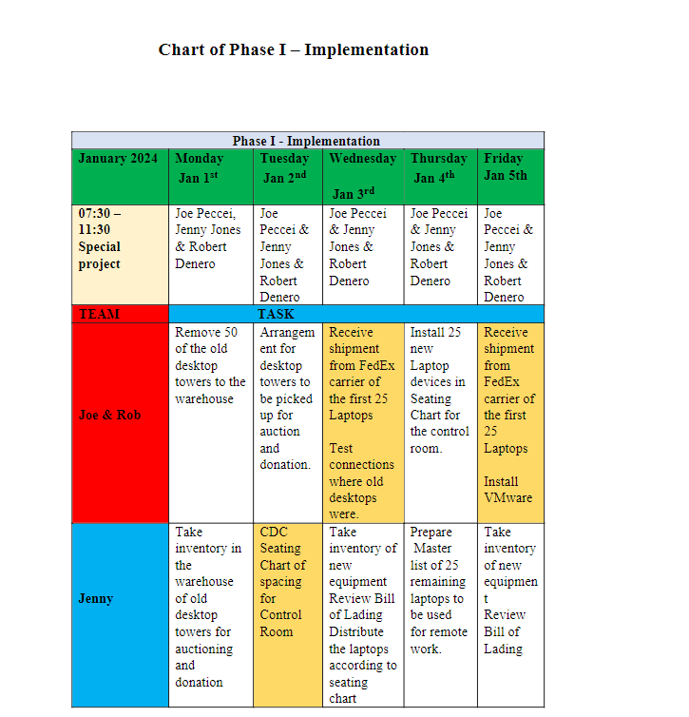

Conclusion
I believe the IT department can complete the installations in a matter of 2 weeks. Reeducation and CBL (computer-based learning) programs can help employees understand the importance of cyber security. The IT department can design the cloud for the CBL after an investment of $8,000. The going subscription rate is $25.00/month.
The update will harden the network against hackers and ransomware. Reeducation and CBL (computer-based learning) programs can help employees understand the importance of cyber security. The IT department can design the cloud for the CBL after an investment in the new infrastructure. The deployment is not one to rush, but there is a need for calculated haste in acquiring the necessary operational plan and instruction on how we will proceed. In any case, we need to stay up to date with the changing times of technology.
The modernity of INFORM is our edge, secret sauce to success and what makes NEW YORK STATE DOT number one in moving more than 20 million people (about the population of New York) throughout the state each day. If there is anything in this notice that is not needed, we will adjust to the best selection.
The INFORM Control Room is updated. Money, human capital, and time have been saved. If there is a need for phase II, please deliver the directive. As shown, the team is efficient. The next logical step is to have a meeting with everyone and advise of the change via E-Mail and then in person. Nothing has changed with the login for staff. Except, Remote working if there are any issues with the setup staff should run into, again, please contact the IT Department for help.

References

- FitzGerald, Jerry, et al. Business Data Communications and Networking. Available from: VitalSource Bookshelf, (14th Edition). Wiley Global Education US, 2020.
- COMPTIA, Threats to Organizations, Why Is Cybersecurity Important | Cybersecurity | CompTIA (2023)
- FitzGerald, Jerry, et al. Business Data Communications
- and Networking. Available from: DeVry, (14th Edition). Wiley Global Education US, 2020. Pg, 52
- COMPTIA, Threats to Organizations, Why Is Cybersecurity Important | Cybersecurity | CompTIA (2023)
- Compare platforms | https://cloud.ibm.com/vmware
- Amazon.com: Kensington Slim Combination Laptop Lock, Security Locking Cable, T-Bar Standard Slot for Laptop Computer(K60600WW) : Electronics
- Amazon.com: Kensington Universal 3-in-1 Combination Laptop Lock, Computer Security Locking Cable - Resettable Version (K62316WW), Black : Electronics
- Pricing (vmware.com)
- Computers, Monitors & Technology Solutions | Dell USA
- Inspiron 16-inch Laptop with AMD Ryzen™ 7000 series Processor | Dell USA
- Cloud Storage Pricing: Wasabi vs Azure, Google & AWS S3 Pricing
- Standard Operating Procedure (SOP) for Triage of Suspected COVID-19 Patients in non-US Healthcare Settings: Early Identification and Prevention of Transmission during Triage | CDC
- Dell - Cart
- Performance Review: Nvidia GeForce RTX 3050 Ti Laptop GPU - NotebookCheck.net Reviews

